**Problem Set 5 Report**

1. Greyscale function

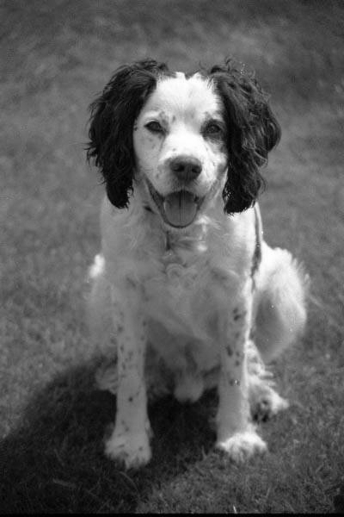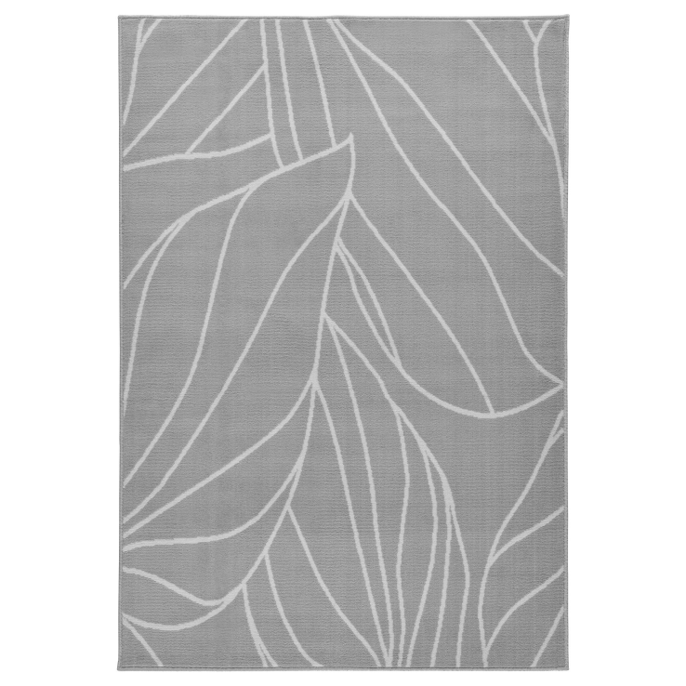

1. Correlation function. Note: I have two correlation functions, one that takes in a filter value and a dimension, and one that takes in a 1D array. Both are basically the same.

/* Correlates a filter value on an image. This function takes in a greyscale BMPImage, and a separable filter with n x n dimensions and a uniform filter value. The filter value parameter should be the value before separation. For instance, if the box filter has all values of 1/49, then 1/49 should be used as input, as this function will separate the box filter into two 1D filters with the value of 1/7. The function then applies the two 1D filters to the image.*/

void correlationFunction(BMPImage *image, float filter, int n) {

float readVal, writeVal, filterVal;

filterVal = sqrt(filter);

//for each pixel in the image

for (int y = 0; y < image->getYSize(); y++) {

for (int x = 0; x < image->getXSize(); x++) {

writeVal = 0;

readVal = 0;

//filter across x

for (int i = -1 * (n / 2); i <= (n / 2); i++) {

int offsetXCoord = x + i;

//padding left

if (offsetXCoord <= 0) {

//use left most value in row

image->readPixel(0, y, readVal, readVal, readVal);

writeVal += readVal * filterVal;

}

//padding right

else if (offsetXCoord >= image->getXSize() - 1) {

//use right most value in row

image->readPixel(image->getXSize() - 1, y, readVal, readVal, readVal);

writeVal += readVal * filterVal;

}

else {

//use value at offset in row

image->readPixel(offsetXCoord, y, readVal, readVal, readVal);

writeVal += readVal * filterVal;

}

}

clampValues(&writeVal);

image->writePixel(x, y, writeVal, writeVal, writeVal);

}

}

//for each pixel in the image

for (int y = 0; y < image->getYSize(); y++) {

for (int x = 0; x < image->getXSize(); x++) {

writeVal = 0;

readVal = 0;

//filter across y

for (int i = -1 * (n / 2); i <= (n / 2); i++) {

int offsetYCoord = y + i;

//padding top

if (offsetYCoord <= 0) {

//use top most value in column

image->readPixel(x, 0, readVal, readVal, readVal);

writeVal += readVal * filterVal;

}

//padding bottom

else if (offsetYCoord >= image->getYSize() - 1) {

//use top most value in column

image->readPixel(x, image->getYSize() - 1, readVal, readVal, readVal);

writeVal += readVal * filterVal;

}

else {

//use value at offset in column

image->readPixel(x, offsetYCoord, readVal, readVal, readVal);

writeVal += readVal * filterVal;

}

}clampValues(&writeVal);

image->writePixel(x, y, writeVal, writeVal, writeVal);

}

}

}

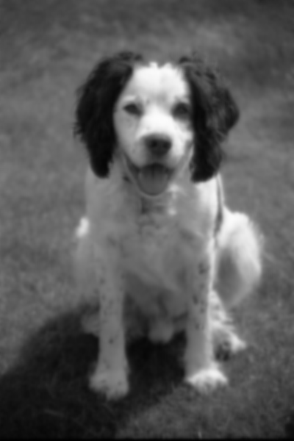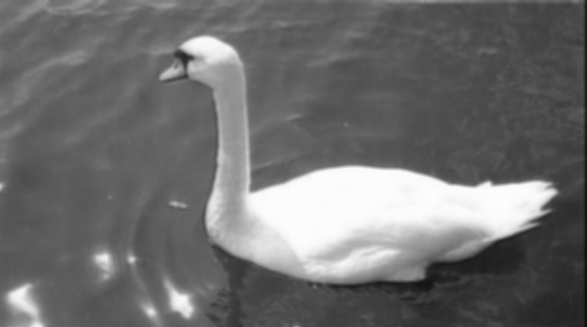

1. Gaussian function

/* Creates a gaussian filter. This function takes in a value for sigma and a pointer to an integer. The function will create a new 1D filter and populate it with values for the gaussian filter. The function will return a pointer to the 1D filter, and will modify the integer pointer to reflect the dimension of the filter. */

float* filterGaussianFunction(float sigma, int *dimen) {

const float PI = 3.1415927;

int filterDimen = 2 * (ceilf(3 * sigma)) + 1;

float *filter = new float[filterDimen];

int j = 0; //index in the filter

//populate the filter

for (int i = -1 * (filterDimen / 2); i <= (filterDimen / 2); i++) {

//calculate filter value and place in filter

//note: I square root the constant because I apply this filter twice, once in x direction

//and once in the y, in the correlation function to simulate a separable filter

filter[j] = sqrt(1 / (sigma * sqrt(2 * PI))) * exp(-1 * (i * i) / (2 * sigma * sigma));

j++;

}

//normalize the filter values

float sum = 0.0f;

for (int i = 0; i < filterDimen; i++) {

sum += filter[i];

}

for (int i = 0; i < filterDimen; i++) {

filter[i] = (filter[i] / sum);

}

*dimen = filterDimen; //"return" the dimension of the filter

return filter; //return the filter

}

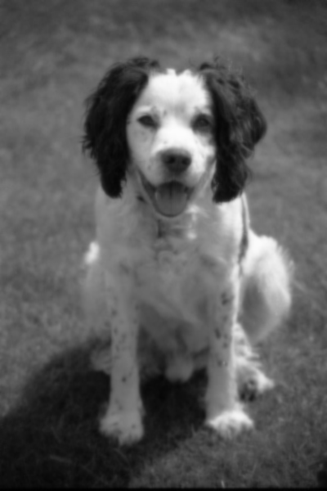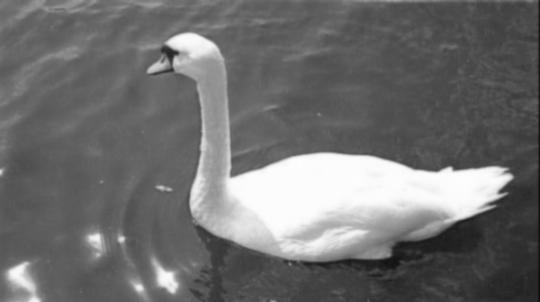

1. Sharpening function

/* Creates a sharpening filter. This function takes in a value for sigma, a pointer to a 1D Gaussian filter and the dimension of the filter. The function will subtract the Gaussian filter from an all-pass filter with a center value of 2, with the rest being zero. The function returns the filter T-G. */

float* filterSharpeningFunction(float sigma, float *filter, int dimen) {

for (int i = 0; i < dimen; i++) {

if (i == (dimen / 2)) {

filter[i] = 2 - filter[i]; //center value of filter T is 2, subtract the center gaussian filter value

}

else {

filter[i] *= -1.0f; //all other values of T are 0, so subtract gaussian filter value at this position

}

}

return filter;

}

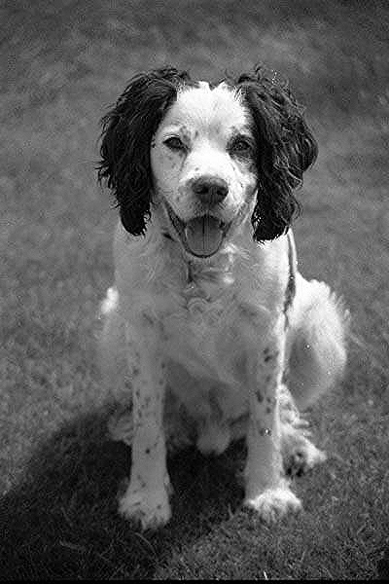

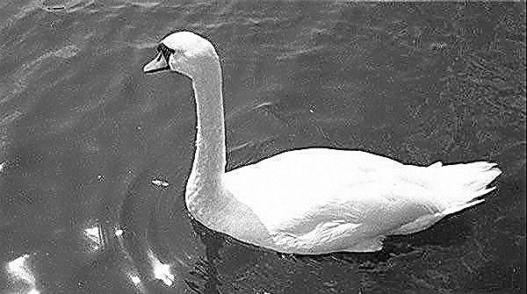

1. Resize function

/* Resizes an image to the scale value. This function takes in a BMPImage, a scale, and a filename to save the new image. The function will take the image parameter and create a new image that is a scaled version of the original, and will save the new scaled image to the saveName parameter. The function uses bilinear interpolation to approximate the pixel values in the new image based on the original. */

void resizeFunction(BMPImage *image, float scale, char *saveName) {

float temp1 = image->getXSize() * scale;

float temp2 = image->getYSize() * scale;

/* compute the image size */

int remainder = (int)fmodl(temp1, 4L);

if (remainder != 0) {

temp1 += (4 - remainder);

}

BMPImage scaledImage = BMPImage(temp1, temp2);

int xLeft, xRight, yTop, yBot;

float topLeftVal, topRightVal, botLeftVal, botRightVal;

float weightX, weightY;

float leftBorderVal, rightBorderVal;

float finalVal;

//for all pixels in the scaled image

for (int scaledX = 0; scaledX < scaledImage.getXSize(); scaledX++) {

for (int scaledY = 0; scaledY < scaledImage.getYSize(); scaledY++) {

//get coordinates of surrounding pixels in original image

xLeft = scaledX / scale;

//make sure we don't exceed bounds of image

if (xLeft == image->getXSize() - 1) {

xRight = xLeft;

}

else {

xRight = xLeft + 1;

}

yTop = scaledY / scale;

//make sure we don't exceed bounds of image

if (yTop == image->getYSize() - 1) {

yBot = yTop;

}

else {

yBot = yTop + 1;

}

//get color value at surrounding pixels in original image

image->readPixel(xLeft, yTop, topLeftVal, topLeftVal, topLeftVal); //top left value

image->readPixel(xRight, yTop, topRightVal, topRightVal, topRightVal); //top right value

image->readPixel(xLeft, yBot, botLeftVal, botLeftVal, botLeftVal); //bot left value

image->readPixel(xRight, yBot, botRightVal, botRightVal, botRightVal); //bot right value

//get weight in the y direction

weightY = (scaledY / scale) - yTop;

//get color value on left border at the y value

leftBorderVal = (weightY * (botLeftVal - topLeftVal)) + topLeftVal;

//get color value on right border at the y value

rightBorderVal = (weightY * (botRightVal - topRightVal)) + topRightVal;

//get weight in the x direction

weightX = (scaledX / scale) - xLeft;

//get color between the two weighted border values

finalVal = (weightX * (rightBorderVal - leftBorderVal)) + leftBorderVal;

scaledImage.writePixel(scaledX, scaledY, finalVal, finalVal, finalVal);

}

}

scaledImage.save(saveName);

}

Dog scaled by 3:

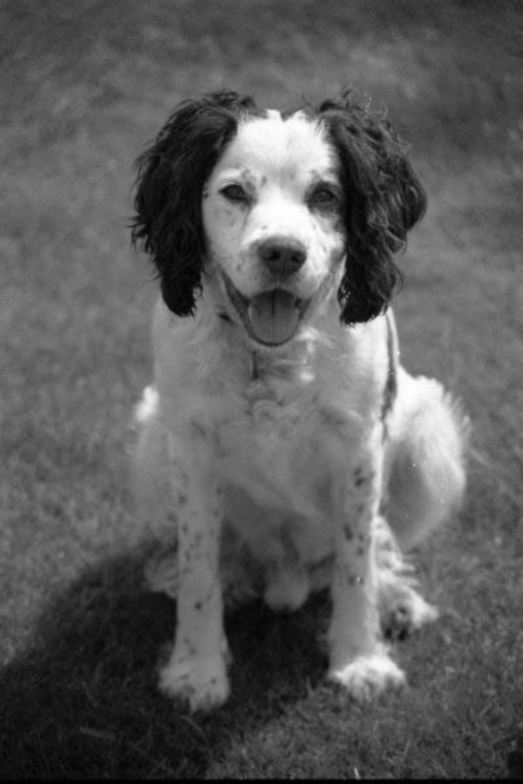

Dog scaled by 0.75

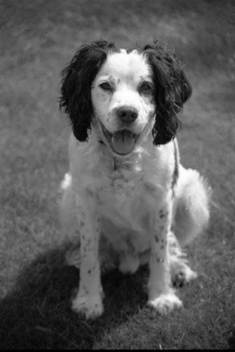

Rug scaled by 0.05 Rug sigma 10 Gaussian and then scaled by 0.05

